**GUIDELINES FOR REFINED EVALUATION AND LOAD RATING OF STEEL MULTI-GIRDER BRIDGES:**

RU439376-3B

**Volume 3B**

Final Report

December 2016

Submitted by

Nicholas Romano

CAIT Research Staff

David Masceri, Ph.D.

CAIT Research Associate

Adriana Trias

Graduate Assistant

Andrés M. Roda, P.E.

Senior Research Manager

Center for Advanced Infrastructure and Transportation (CAIT)

Rutgers, the State University of New Jersey

100 Brett Road

Piscataway, NJ 08854



New Jersey Department of Transportation

1035 Parkway Ave.

Trenton, NJ 08625

In cooperation with  
New Jersey Department of Transportation

Bridge Engineering and Infrastructure Management

and

U.S. Department of Transportation

Federal Highway Administration**Disclaimer Statement**

The contents of this report reflect the views of the author(s) who is (are) responsible for the facts and the accuracy of the data presented herein. The contents do not necessarily reflect the official views or policies of the New Jersey Department of Transportation or the Federal Highway Administration. This report does not constitute a standard, specification, or regulation.

|  |  |  |  |  |
| --- | --- | --- | --- | --- |
| 1. Report No.  RU439376-3B | 2. Government Accession No. | | 3. Recipient’s Catalog No. | |
| 4. Title and Subtitle  Guidelines for Refined Evaluation and Load Rating of Steel Multi-Girder Bridges: Volume 3B | | | 5. Report Date  December 2016 | |
| 6. Performing Organization Code  CAIT/Rutgers | |
| 7. Author(s)  Nicholas Romano, David Masceri, Ph.D., Adriana Trias | | | 8. Performing Organization Report No.  RU439376-3B | |
| 9. Performing Organization Name and Address  Center for Advanced Infrastructure and Transportation Rutgers, The State University of New Jersey 100 Brett Road Piscataway, NJ 08854 | | | 10. Work Unit No. | |
| 11. Contract or Grant No. | |
| 12. Sponsoring Agency Name and Address  Federal Highway Administration  U.S. Department of Transportation  Washington, D.C. 20590  New Jersey Department of Transportation  PO 600  Trenton, NJ 08625 | | | 13. Type of Report and Period Covered  Final Report  03/15/16 – 12/31/16 | |
| 14. Sponsoring Agency Code | |
| 15. Supplementary Notes | | | | |
| 16. Abstract  Finite Element (FE) analysis of multi-girder bridges provides an effective way of predicting the response of a structure to a wide variety of loading conditions. Often the predicted responses are used to compute a conservative measure of the structure’s reserve capacity in the form of rating factors. This document is meant to instruct and inform NJDOT staff on the intentions and intricacies of the modeling theory and refined evaluation and load rating (LRFR) employed by CAIT research staff for the steel multi-girder bridges included in this project. This document may serve as a set of guidelines for performing the tasks necessary for NJDOT staff to perform refined modeling, evaluation, and load rating of steel multi-girder bridges in the future. | | | | |
| 17. Key Words  Finite Element Modeling, Refined Evaluation, Load Rating | | 18. Distribution Statement  No Restrictions | | |
| 19. Security Classification (of this report)  Unclassified | 20. Security Classification (of this page)  Unclassified | | 21. No. of Pages  XX | 22. Price |

TECHNICAL REPORT STANDARD TITLE PAGE

**Form DOT F 1700.7** (8-69)

**ACKNOWLEDGEMENTS**

The research team would like to acknowledge the support of the New Jersey Department of Transportation on this project under the direction of Eddy Germain. The technical review was guided by Greg Renman, Jack Evans, Mula Reddy and their staff at the Structural Evaluation Unit. In addition, special thanks are extended to the New Jersey Department of Transportation State Transportation Engineer, E. David Lambert III and Nat Kasbekar who supported and promoted the development of this Program. This project was also made possible by the Federal Highway Administration.

**TABLE OF CONTENTS**

EXECUTIVE SUMMARY 1

Foreword 2

Modeling 2

Structure Dimensions & Material Properties 2

Model Form 3

Girders & Diaphragms 5

Deck 6

Sidewalk & Barriers 6

Boundary Conditions 6

Composite Action 7

Element Discretization 7

Modeling of Haunches 7

Modeling of Barriers 8

Error Screening 8

Dead Load & Live Load Analysis 10

Dead Load 10

Initial Dead Load (DC1) 10

Superimposed Dead Load (DC2) 10

Wearing Surface (DW) 11

Live Load 12

Strand7 Load Influence Solver 12

Definition of Live Load Cases 13

Results for Evaluation 18

Locations of Results Extraction 18

Typical Simply Supported Multi-Girder Bridges 18

Typical Multiple-Span Continuous Multi-Girder Bridges 18

Non-Typical Bridges 18

Composite vs. Non-Composite for Flexure 19

Flexure 19

Shear 19

Section Properties 20

Non-Composite Section Properties 20

Location of the Non-Composite Neutral Axis, yNC 21

Moment of Inertia, INC 21

Section Modulus, SNC 22

Composite Section Properties 22

Long Term vs. Short Term Composite 22

Effective Width & Area of Concrete Deck 23

Location of the Composite Neutral Axis, yLT & yST 23

Composite Moment of Inertia, ILT & IST 24

Composite Section Moduli, SLT & SST 24

Resistance Calculations 25

Load Rating 35

System & Condition Factor 36

Nominal Resistance 37

LRFD Load Factors for Resistance, Dead Load, and Live Load 38

Reporting of Controlling Load Rating 38

**LIST of Figures**

Figure 1. 3D geometry of a steel multi-girder bridge using beam, shell, and link elements (Masceri 2015) 4

Figure 2. 3D geometry of a steel multi-girder bridge using shell elements only (Masceri 2015) 5

Figure 3. Typical girder/diaphragm/link element connection for steel multi-girder bridge models (Masceri 2015) 6

Figure 4. Example boundary conditions for a two-span continuous bridge (Masceri 2015) 7

Figure 5. Type HL-93 Truck Strand7 Load Path Configuration 14

Figure 6. Standard HL-93 Truck. AASHTO 3.6.1.1.2.2-1 Characteristics of Design Truck 15

Figure 7. Type 3 AASHTO Legal Truck defined in AASHTO Manual for Bridge Evaluation. 15

Figure 8. Type 3S2 NJDOT Legal Truck. 16

Figure 9. Type 3-3 AASHTO Legal Truck defined in AASHTO Manual for Bridge Evaluation. 16

Figure 10. Type 3-3 75% defined in AASHTO Manual for Bridge Evaluation. 17

Figure 11. SU4 Truck defined in AASHTO Manual for Bridge Evaluation. 17

Figure 12. SU5 Truck defined in AASHTO Manual for Bridge Evaluation. 17

Figure 13. SU6 Truck defined in AASHTO Manual for Bridge Evaluation. 18

Figure 14. SU7 Truck defined in AASHTO Manual for Bridge Evaluation. 18

Figure 15. Reference diagram for calculation of non-composite section properties. 21

Figure 16. Reference diagram for calculation of composite section properties. 23

Figure 17. Reference diagram for calculation of long term and short term composite section moduli. 26

**LIST of Tables**

Table 1. Error screening tasks for global geometry and component dimensions. 8

Table 2. Error screening tasks for modeling. 9

Table 3. Component states for initial dead load. 10

Table 4. Component states for superimposed dead load. 11

Table 5. Component states for dead load of wearing surface. 11

Table 6. Multiple Presence Factors (m) taken from AASHTO LRFD Bridge Design Specifications, Table 3.6.1.1.2-1. 13

Table 7. Modular ratio for transformation of short term and long term composite section 23

Table 8. Compact requirements for composite sections in positive flexure. 27

Table 9. Compression flange slenderness ratios for flange lateral buckling resistance of non-composite sections in negative flexure. 31

Table 10. Limits of unbraced length for the compression flange lateral torsional buckling resistance of non-composite sections in negative flexure. 32

Table 11. Condition Factors. 37

Table 12. System Factors. 37

Table 13. Values of resistance used for load rating. 38

Table 14. Load and resistance factors for load rating. 39

**EXECUTIVE SUMMARY**

Finite Element (FE) analysis has become increasingly prevalent in the many fields performing structural analysis. This powerful tool is capable of predicting structural responses with greater accuracy than many of the alternative analysis models (e.g. single-line girder, grillage), and is especially valuable for structures whose geometric complexity renders the alternative models inadequate. This document provides a suggested framework for conducting a refined evaluation and load rating of a steel multi-girder bridge while following the provisions set forth in the AASHTO Load and Resistance Factor Rating (LRFR) specifications.

FE analysis was utilized to conduct load ratings of several steel multi-girder bridges in 2016. The procedures followed have been generalized to provide guidelines for performing refined load ratings of similar bridge types. The following steps for conducting a refined load rating have been documented:

1. FE modeling decisions, model creation, and error screening
2. Performing dead load and live load analysis
3. Extracting member level results
4. Computing member level capacity
5. Calculating rating factors

While effort has been made to provide a full description of the many steps, it is recommended that the refined load rating be performed by someone with experience in both load rating methodology and FE modeling. This set of guidelines is not intended to fully encompass every aspect of FE modeling or load rating, and thus if further information is required, it is recommended that appropriate specifications and FE instructional material be consulted.

# Foreword

Finite Element (FE) analysis of multi-girder bridges provides an effective way of predicting the response of a structure to a wide variety of loading conditions. Often the predicted responses are used to compute a conservative measure of the structure’s reserve capacity in the form of rating factors. This document is meant to instruct and inform NJDOT staff on the intentions and intricacies of the modeling theory and refined evaluation and load rating (LRFR) employed by CAIT research staff for the steel multi-girder bridges included in this project. This document may serve as a set of guidelines for performing the tasks necessary for NJDOT staff to perform refined modeling, evaluation, and load rating of steel multi-girder bridges in the future.

# Modeling

This section provides information about gathering of structural dimensions and details, finite element (FE) model construction, and FE model error screening.

## Structure Dimensions & Material Properties

FE model building benefits from myriad structure dimensions/details, material properties, and many other sources of as-built information. At the onset of the activity, gather and collect all available construction documents, inspection reports and other documents associated with the structure. If no plans are available, or if there is missing information, coordinate a field visit to collect dimensions and material properties or establish and document justifiable assumptions based on engineering judgement. The following list provides the typical, but not limited to, global dimensions and component details required before beginning to build a model:

* Number of spans/continuity
* Span Length(s)
* Bridge Width (Roadway Width, Out-to-out Width)
* Number of Lanes & Lane Widths
* Skew
* Girder Spacing & Number of Girders
* All applicable girder dimensions (cross-section dimensions, curvature, end overhang, etc.)
* Overhang Width/Thickness
* Deck/Wearing Thickness
* Haunch Thickness
* Barrier Section (Height, Width, or other dimensions describing the cross-section)
* Sidewalk Dimensions
* Number of Diaphragms and Diaphragm Spacing
* Diaphragm Section
* Material Properties (Concrete Strengths, Steel Yield Strength)

## Model Form

There exists a wide range of modeling techniques that may be used to simulate the behavior of common multi-girder bridges. Two modeling techniques are discussed in these guidelines: the element-level and shell element methods of modeling. Both methods can reasonably simulate most bridge responses but each has its own limitations.

The element-level model is the most common class of 3D finite element models employed for constructed systems (David M. Masceri, 2015). This model employs one-dimensional elements (beam elements) to model girders, diaphragms, and barriers, and two-dimensional (plates/shell elements) to model the deck and sidewalks. In an element-level model, a girder is discretized into 1D beam elements with the cross-section applied through the definition of geometric properties (e.g. area, moment of inertia, etc.). Link elements are used to connect components (i.e. girders to the deck, diaphragms to the girders, etc.) to remain consistent with the 3D geometry of the structure. Figure 1 below is a schematic that shows how the 3D geometry of the bridge is simulated using the beam, shell, and link elements described. An element-level model can reasonably simulate most bridge responses; however, the shortcomings of this method include: (1) an inability to effectively simulate warping deformation of girders (associated with torsion), and (2) an inability to simulate localized stresses (i.e. stress concentrations) associated with geometric discontinuities. These shortcomings may be critical when modeling construction sequences for complex bridges (White, 2012), or for advanced fatigue/fracture assessment, however they are not relevant for the global limit states that are evaluated in load rating. White et al. (2012) provides a comprehensive evaluation of different model forms and the various cases for which one model may be better suited than another.

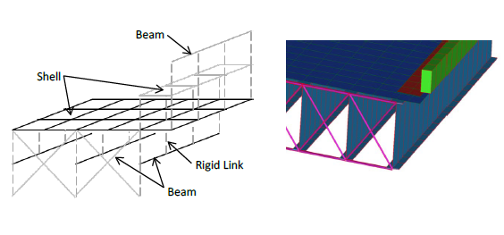

Figure . 3D geometry of a steel multi-girder bridge using beam, shell, and link elements (David M. Masceri, 2015)

In contrast, the shell element model employs plates and shell elements exclusively. As a result, the most significant distinction between element-level and shell element models of multi-girder bridges is that the girder in shell element models are discretized vertically, laterally, and longitudinally using shell/plate elements. Additionally, link elements are used along the cross-section of the girder to enforce displacement and strain compatibility. Unlike the element-level model, the shell element model allows for accurate simulation of the warping of girders due to torsion, and the simulation of localized stresses (i.e. stress concentrations). Some caution is advised when using shell element models as these models may output local stress concentrations that do not manifest in the as-built structure. Moreover, shell element models may be undesirable for common use as model construction, computation, and result extraction activities are more time consuming and more difficult than with element-level models. Figure 2 below shows how the 3D geometry of the bridge is simulated using the in a shell element model.

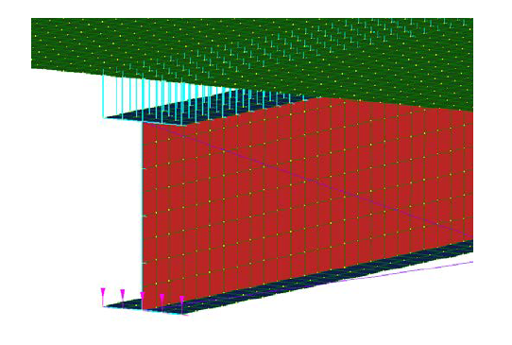

Figure . 3D geometry of a steel multi-girder bridge using shell elements only (David M. Masceri, 2015)

Fatigue/fracture assessment and the warping deformation associated with torsion is not of concern for the traditional load rating of typical multi-girder bridges. Therefore, unless otherwise noted, all steel multi-girder bridges included in this report are modeled using the element-level modeling method. The following sections provide a more detailed description of the modeling of each component of the bridge superstructure.

## Girders & Diaphragms

For analysis using the element-level model, girders and diaphragms are modeled using 2D beam elements. The section geometry and material properties of the girders and diaphragms are assigned to the beam element property in the FE software (CAIT uses Strand7). The beam elements are placed at the centroid of the section. Nodes are placed at the top and bottom surfaces of the girder flanges. Rigid links are used to enforce compatibility between the top and bottom surfaces of the girder flanges by connecting the girder centroid to the top and bottom flange nodes. These nodes may be used to connect diaphragms, enforce composite action by linking to the deck, or as boundary nodes. Depending on the type and configuration of the diaphragm, the diaphragm beam elements can connect to the top or bottom flange nodes or to the girder centroid node. If connections exist in other locations on the girder, nodes may be placed at the connection location on the girder and linked to the top/bottom flange nodes or girder centroid node. Figure 3 shows a schematic of a typical girder-diaphragm connection.

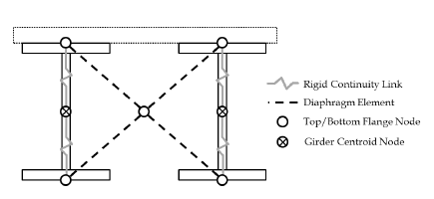

Figure . Typical girder/diaphragm/link element connection for steel multi-girder bridge models (David M. Masceri, 2015)

## Deck

The concrete deck is modeled using three- and four-node shell elements depending on the configuration needed. These shell elements are assigned a bending and membrane thickness equivalent to the thickness of the concrete deck. Deck nodes are located at the center of the shell element thickness. Composite action of the deck may be enforced by connecting the girder nodes and the deck nodes with rigid link elements. Reinforcement is not considered in the model.

## Boundary Conditions

Figure 4twos

Figure . Example boundary conditions for a two-span continuous bridge (David M. Masceri, 2015)

## 

## Modeling of Haunches

For structures with a concrete haunch, modeling the geometry of the haunches using beam or shell elements is not required. Instead, the girder beam elements may be offset from the centroid of the girder section by a distance equivalent to the depth of the concrete haunch. The offset serves to effectively increase the moment arm between the centroid of the deck and the centroid of the steel beam to match the geometry of the actual structure. It is important to note that this method ignores the mass of the haunches. Therefore, when using this method, the modeling engineer must decide whether to include the dead load due to the concrete haunches. This may be accomplished in several ways, the simplest of which is to include distributed loads in the model corresponding to the weight of the haunch.

This decision was made after comparing the responses of a sample structure under its own weight for three methods of modeling the haunch (offsetting the girder beam elements and adding a distributed load, or explicitly modeling the haunches with beam and shell elements). The responses compared were those used for load rating: bending moment and axial force. A negligible difference in response (less than 5%) was observed between the three methods. In fact, using the offset method proved to decrease the time needed for modeling and results extraction. As such, haunches may be considered by using the offset method described.

## Modeling of Sidewalks & Barriers

.The stiffness contribution of steel or concrete barriers may be ignored in analysis. Masceri (2015) found that when barrier stiffness was included (assuming continuity along the entire length of the barrier as well as full continuity with the deck) rating factors for interior and exterior girders increased compared to when barrier stiffness was ignored. This optimal level of continuity is unrealistic and the actual stiffness of the barriers is uncertain due to construction details (saw cuts, rebar continuity, etc.). Given these findings, it is conservative to ignore the stiffness of the barriers. This is accomplished by assigning the barrier beam elements with an arbitrarily small modulus of elasticity.

Additionally, the barrier element may be assigned a rectangular cross-section using the largest height and width dimensions of the barrier. Assuming a rectangular cross-section with the largest dimensions can save modeling time for barriers with complex shapes and is conservative as it includes additional dead load from the added material.

## Element Discretization

Element discretization is relative to the size of the structure. It is important to coordinate the mesh sizing between the girder and deck elements so that adjacent nodes line up in parallel or perpendicular global grid coordinates. A few rules of thumb are as follows: (1) the aspect ratio of shell element dimensions should generally be limited to 2:1, with none having an aspect ratio greater than 5:1, (2) elements should be discretized at approximately 1/6 to 1/8 of the girder spacing (David Masceri, 2014).

## Error Screening

After a model is built and before analysis is conducted, the model is error screened for proper geometric and material properties as well as modeling decisions by someone other than the original modeler. If an error is found, it is noted for the original modeler to make the proper corrections. Table 1 and Table 2 below provide a list of all aspects of the model that are checked during errors screening.

Table . Error screening tasks for global geometry and component dimensions.

|  |  |
| --- | --- |
| GLOBAL GEOMETRY & COMPONENT DIMENSIONS | DESCRIPTION |
| Global Geometry | Verify that the span length, width, skew, etc. corresponds to the drawings or field measurements |
| Location of Supports | Verify that the supports reside in the proper geometric location |
| Girder Dimensions & Locations | Verify that the proper cross sections are assigned and the girder beam elements reside in the proper geometric location (girder spacing, offset, etc.) |
| Haunch Representation | Verify that the haunch is properly represented (either by elements with the proper geometry or that the correct offset is assigned) |
| Deck Dimensions & Locations | Verify that the proper thickness is assigned and the deck shell elements reside in the proper geometric location and have the proper global dimensions |
| Barrier Dimensions & Locations | Verify that the proper cross sections are assigned and the barrier beam elements reside in the proper geometric location |
| Diaphragm Dimensions & Locations | Verify that the proper cross sections are assigned and the diaphragm beam elements reside in the proper geometric location and have the proper configuration |

Table . Error screening tasks for modeling.

|  |  |
| --- | --- |
| MODELING ASPECTS | DESCRIPTION |
| Material Properties | Verify that the proper material properties are assigned to all elements |
| Clean Mesh | Verify that there are no duplicated node, beam or shell elements |
| Boundary Conditions | Verify that the proper boundary conditions are assigned at each support location |
| Connectivity | Verify that all elements in the model have the proper connectivity (through rigid links or sharing of nodes) |
| Live Load Path | Verify that all load paths are properly defined and assigned in the proper location |
| Dead Load | Verify that the total dead load of the model approximates that of the actual structure |

# Dead Load & Live Load Analysis

## Dead Load

Three dead load cases are considered separately, initial dead load, superimposed dead load, and dead load from the wearing surface. Each load case is defined by manipulating the mass and stiffness through material properties (density and modulus of elasticity) of specific components of the structure. This section provides a description of each dead load case as well as the application of each case.

### Initial Dead Load (DC1)

Included in the initial dead load case is the self-weight of the steel components (girders, diaphragms, and connections) as well as the self-weight of the deck. For analysis of this load case, the stiffness of the steel component is included but the stiffness of the deck is not. This is achieved by setting the modulus of elasticity for the deck to an arbitrarily small value before running the linear static solver in Strand7, ensuring that the dead load of the un-cured concrete is accounted for while providing no stiffness. Table 3 below summarizes the state of each component for this load case.

Table . Component states for initial dead load.

|  |  |  |  |  |
| --- | --- | --- | --- | --- |
| **Component(s)** | **Mass** | **Stiffness** | **Density** | **Modulus** |
| Girders, Diaphragms, Connections | Yes | Yes | Specified density of component(s) | Specified modulus of component(s) |
| Deck | Yes | No | Specified density of component(s) | 1.0 lb/in2 |

### Superimposed Dead Load (DC2)

Superimposed dead load considers only the self-weight of the components that were built after the deck has cured (e.g. sidewalks and barriers). The stiffness of these components is ignored by setting their modulus of elasticity to an arbitrarily small value. The stiffness of the cured concrete deck is included but the mass of the deck and all steel components (girders, diaphragms, and connections) is ignored for this load case by setting the density of each component to 0. This ensures that the dead load for each component is only accounted for once.

Table . Component states for superimposed dead load.

|  |  |  |  |  |
| --- | --- | --- | --- | --- |
| **Component(s)** | **Mass** | **Stiffness** | **Density** | **Modulus** |
| Girders, Diaphragms, Connections | No | Yes | 0 lb/in3 | Specified modulus of component(s) |
| Deck | No | Yes | 0 lb/in3 | Specified modulus of component(s) |
| Sidewalks, Barriers | Yes | No | Specified density of component(s) | 1.0 lb/in2 |

### Wearing Surface (DW)

The wearing surface may be applied to the structure in one of two ways. The first is to use non-structural lumped mass on the deck nodes with a mass equivalent to that of the wearing surface over the tributary area of each node. The second is to model the wearing surface as a second layer of shell elements with the proper material properties, thickness, and geometric offset. The stiffness of the wearing surface is not considered and therefore only contributes to the overall dead load. Stiffness of the barriers and sidewalks is also ignored. Table 5 below summarizes the state of each component for this load case.

Table . Component states for dead load of wearing surface.

|  |  |  |  |  |
| --- | --- | --- | --- | --- |
| **Component(s)** | **Mass** | **Stiffness** | **Density** | **Modulus** |
| Girders, Diaphragms, Connections | No | Yes | 0 lb/in3 | Specified modulus of component(s) |
| Deck | No | Yes | 0 lb/in3 | Specified modulus of component(s) |
| Sidewalks, Barriers | No | No | 0 lb/in3 | 1.0 lb/in2 |
| Wearing Surface | Yes | No | Specified density of component(s) | 1.0 lb/in2 |

## Live Load

Live load is analyzed using Strand7’s load path feature and the built-in Load Influence Solver. This section defines the load cases considered (for LRFR HL-93, LFR HS20, and respective legal loading) and provides detailed documentation for the analysis of live loads conducted with Strand7.

### Strand7 Load Influence Solver

Strand7’s Load Influence Solver is used to determine the influence that a point load or series of point loads has on a response at a specified location. In Strand7, Response Variables (RVs) may be assigned to nodes or elements at locations where a maximum response (shear force, bending moment, etc.) is anticipated. Load paths are defined for each loading scenario and the Load Influence Solver is used to determine the loading configuration that gives the maximum response at the location of each RV. Final analysis is conducted using the static loading conditions developed through the load influence solver.

#### Response Variables for Flexure

RVs for flexure are assigned to beam elements at locations along the girder where the load rating is desired. They may be placed at locations where the maximum flexure response of the total demand envelope (positive or negative) will occur, or at locations of interest to the modeling engineer (e.g. at the location where a section changes or at a connection point). For typical multi-girder bridges, the location of maximum flexure response depends on the structure type and/or continuity of the bridge as well as the support conditions. There are several heuristic based rules that exist that explain where the maximum flexure response will occur. Under typical loading conditions, simple span bridges generally experience maximum positive flexure at mid span, therefore flexure RVs are typically assigned to each member at 0.5L. Multiple span continuous bridges experience maximum positive flexure between supports at a location between 0.35L and 0.45L. For bridges with a skew, different span lengths, or nonsymmetrical plan arrangements the location of maximum positive dead and live load will vary. For this reason, placement of the RV to obtain the maximum flexure response of the total demand envelope may require an iterative approach. This is left to the discretion of the modeling engineer.

#### Response Variables for Shear

For most typical bridges (symmetric, multi-girder bridges) maximum shear will occur in members directly over the supports. RVs for shear are placed in these locations. For non-typical bridges, a controlling shear response may also occur at connection locations. For these special cases, the locations of the RVs are left to the discretion of the engineer.

### Definition of Live Load Cases

Load path templates are created for all design and legal load trucks for LRFR. Each template contains the properties for each load case, including the truck axle spacing and loading configuration as well as lane loading. Several aspects are considered when assigning Live Load (LL) properties and configurations to the bridge models using the load path feature in Strand7. The number of lanes is defined in the load path template and is determined as the integer part of the road width (clear distance from curb to curb) divided by 12ft. Lane crowding is accounted for in the load path by allowing the trucks to shift one foot from the center of the lane in either direction. Multiple Presence Factors (*m*) taken from AASHTO LRFD Specifications are assigned in the load path template to account for the probability of simultaneous lane occupation. Table 6 below contains the multiple presence factors used for LRFR. Additionally, an impact factor of 1.33 is applied to each load per AASHTO LRFD Specifications. Figure 5 is a screen shot of the load path template for LRFR HL-93 loading, presented as an example.

Table . Multiple Presence Factors (m) taken from AASHTO LRFD Bridge Design Specifications, Table 3.6.1.1.2-1.

|  |  |
| --- | --- |
| Number of Lanes | LRFR |
| 1 | 1.20 |
| 2 | 1.00 |
| 3 | 0.85 |
| > 3 | 0.65 |

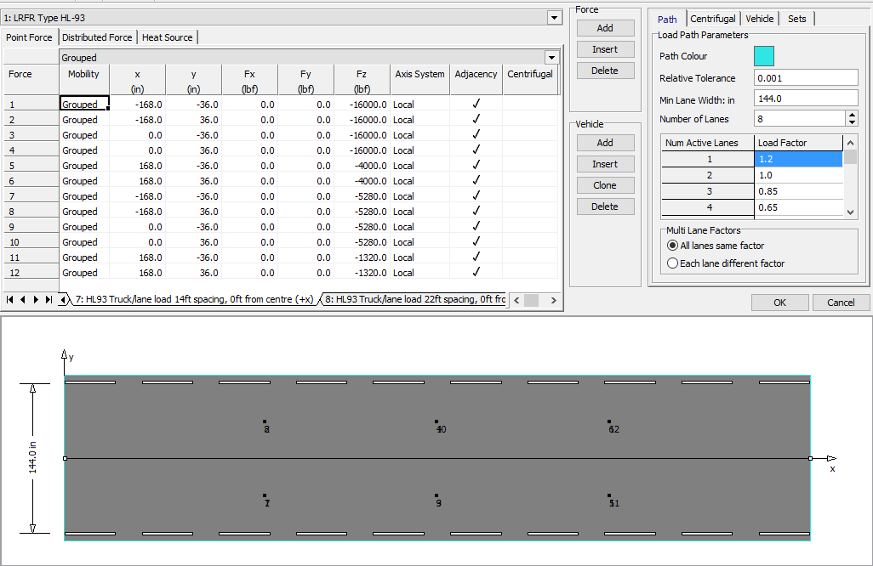

Figure . Type HL-93 Truck Strand7 Load Path Configuration

The specifications for each truck type are provided herein.

#### HL-93

The configuration of the HL-93 loading is shown in Figure 6 below. The loading configurations created in the load path template represent the different truck arrangements for the HL-93 truck and lane loading defined in the AASHTO Manual for Bridge Evaluation. The loading scenarios for HL-93 are listed below.

* HL-93 Design truck (Spacing 14’-14’)
* HL-93 Design truck (Spacing 14’-22’)
* HL-93 Design truck (Spacing 14’-30’)
* 90% of dual HL-93 design truck (Spacing 14’-14’), internal spacing of 50’ (for continuous only)
* 90% of dual HL-93 design truck (Spacing 14’-14’), internal spacing of 100’ (for continuous only)



* Design Lane load (640 lb/ft)
* Tandem truck type

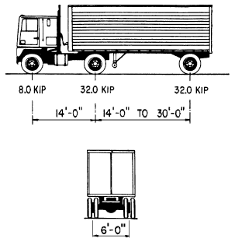

Figure . Standard HL-93 Truck. AASHTO 3.6.1.1.2.2-1 Characteristics of Design Truck

#### ***Type*** 3

The load configuration defined in Strand7 for LRFR Type 3 Legal Load is shown in Figure 7 below (without the applied impact factor). The axle loads for LRFR Type 3 with applied impact factor are 21.28K, 22.61K and 22.61K.

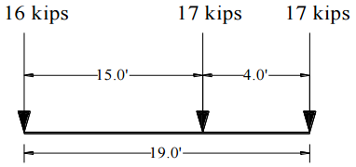

Figure . Type 3 AASHTO Legal Truck defined in AASHTO Manual for Bridge Evaluation.

#### Type 3S2

The load configuration defined in Strand7 for LRFR Type 3S2 Legal Load is shown in Figure 8 below (without the applied impact factor). The axle loads for LRFR Type 3S2 with applied impact factor are 15.96K, 22.61K, 22.61K, 22.61K and 22.61K.

12 kips

17 kips

17 kips

17 kips

17 kips

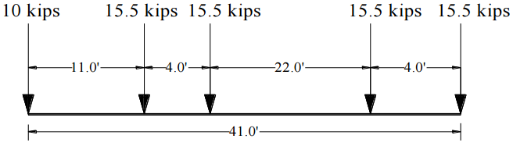

Figure . Type 3S2 NJDOT Legal Truck.

#### Type 3-3

The load configuration defined in Strand7 for LRFR Type 3-3 Legal Load is shown in Figure 9 below (without the applied impact factor). The axle loads for LRFR Type 3-3 with applied impact factor are 15.96K, 15.96K, 15.96K, 21.28K, 18.62K and 18.62K.

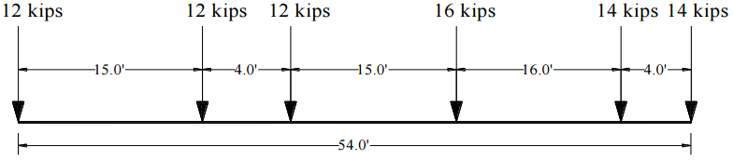

Figure . Type 3-3 AASHTO Legal Truck defined in AASHTO Manual for Bridge Evaluation.

#### Type 3-3 75% (For multiple-span continuous only)

The load configuration defined in Strand7 for LRFR Type 3-3 75% Legal Load is shown in Figure 10 below (without the applied impact factor). The axle loads for LRFR Type 3-3 75% with applied impact factor are 11.97K, 11.97K, 11.97K, 15.96K, 13.96K and 13.96K.

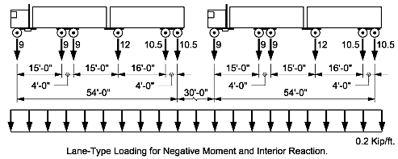

Figure . Type 3-3 75% defined in AASHTO Manual for Bridge Evaluation.

#### SU4

The load configuration defined in Strand7 for LRFR SU4 Legal Load is shown in Figure 11 below (without the applied impact factor). The axle loads for LRFR SU4 with applied impact factor are 15.96K, 10.64K, 21.61K and 21.61K.

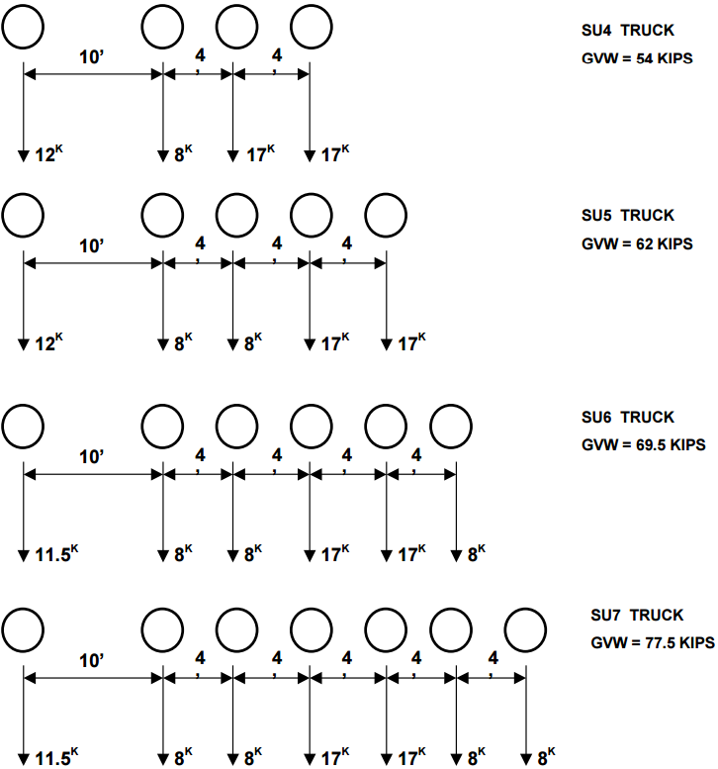

Figure . SU4 Truck defined in AASHTO Manual for Bridge Evaluation.

#### SU5

The load configuration defined in Strand7 for LRFR SU5 Legal Load is shown in Figure 12 below (without the applied impact factor). The axle loads for LRFR SU5 with applied impact factor are 15.96K, 10.64K, 10.64K, 21.61K and 21.61K.



Figure . SU5 Truck defined in AASHTO Manual for Bridge Evaluation.

#### SU6

The load configuration defined in Strand7 for LRFR SU6 Legal Load is shown in Figure 13 below (without the applied impact factor). The axle loads for LRFR SU6 with applied impact factor are 15.29K, 10.64K, 10.64K, 21.61K, 21.61K and 10.64K.



Figure . SU6 Truck defined in AASHTO Manual for Bridge Evaluation.

#### SU7

The load configuration defined in Strand7 for LRFR SU7 Legal Load is shown in Figure 14 below (without the applied impact factor. The axle loads for LRFR SU7 with applied impact factor are 15.29K, 10.64K, 10.64K, 21.61K, 21.61K, 10.64K and 10.64K.



Figure . SU7 Truck defined in AASHTO Manual for Bridge Evaluation.

# Results for Evaluation

## Locations of Results Extraction

The response locations of interest – from which results are extracted – are described in this section for typical and non-typical bridges. Typical bridges represent the population bridges sharing similar geometric properties (i.e. symmetrical, multi-girder, etc.) such as common highway overpass bridges. Non-typical describe bridges with a rather complex design (i.e. thru-girder/floor beam systems, masonry arches, and other more signature bridges). Results extraction may be demand driven (i.e. results are extracted from where the maximum response occurs) or capacity driven (i.e. results are extracted from any location where the engineer wishes to evaluate the capacity).

### Typical Simply Supported Multi-Girder Bridges

For flexure, results are extracted from the locations where the flexure RVs were placed. This is where positive flexure responses are maximum. For shear, results are extracted from the location where the shear RVs were placed. This is where shear responses are maximum.

### Typical Multiple-Span Continuous Multi-Girder Bridges

For multiple-span continuous structures, flexure results are extracted from the locations where the flexure RVs were placed. Shear results are extracted from the location where the shear RVs were placed.

### Non-Typical Bridges

The locations of interest for non-typical bridges are left to the discretion of the person conducting the refined evaluation of the structure. These will typically exist were the maximum positive and/or negative flexure and shear responses occur.

## Composite vs. Non-Composite for Flexure

Total composite flexure demands are extracted from each location and evaluated against the resistance of the composite or non-composite section depending on the location and the response (e.g. positive or negative flexure). Unless noted otherwise, cross-sections in regions of positive flexure are considered composite and the total composite demand extracted from the model is evaluated against the resistance of the fully composite section. Cross-sections in regions of negative flexure are considered non-composite. That is, the deck is assumed to provide no resistance to tensile stresses. The total composite demand extracted from the model is evaluated against the resistance of the non-composite (beam only) section in the negative moment region.

## Flexure

For flexure responses, components of total moment are extracted from the beam and adjacent shell elements. In order to compute the full composite moment at the particular cross-section of interest, three response components were extracted from each location. These components are major axis bending moment in the beam element (M1), axial force in the beam element (P), and bending moment in the adjacent shell elements (M22). The adjacent shell elements are those in a transverse row within the effective width of each longitudinal member. The bending moment in the adjacent shell elements is only considered for load cases where the stiffness of the deck is considered (i.e. all except initial dead load). Equation 1 below gives the calculation used to determine the total moment that acts on the cross-section.

|  |  |
| --- | --- |
|  | (1) |
| Where,  *y = the distance between the centroid of the deck and the centroid of the beam* |  |

Flexural responses are evaluated for both composite and non-composite sections depending on the response type and location.

## Shear

The method of extracting shear responses depends on the location of where the response is being extracted. Shear responses over exterior supports are taken as the reaction at the support. This conservatively assumes that the value of the reaction is the absolute maximum shear in the girder. Shear responses over interior supports or at element connection locations are taken as the absolute maximum shear response in the beam element assuming there is no contribution from the concrete deck. The decision to extract shear responses using these two methods was a result of findings from a parametric study conducted by CAIT research personnel. It was found that shear responses over exterior supports differed from what was expected depending on the model type an element discretization. This was not the case, however, for responses over interior supports.

# Section Properties

Section properties are independent from the evaluation method (LFR, LRFR). They are based on principles of Mechanics of Materials and geometric properties of the cross-section. The cross-section properties are used to define the mechanical behavior of the girder’s cross section (for composite or non-composite sections). These properties are used in calculations for both LFR and LRFR to compute response values and member capacity.

## Non-Composite Section Properties

As previously stated, non-composite sections are defined as the “beam only” section, where it is assumed that the deck does not provide any resistance to tension or compression. Section properties of the non-composite section are denoted by the subscript “*NC*” and are calculated using only the geometric properties of the beam. Non-composite section properties are used when evaluating initial dead load and for flexure in the negative moment region for superimposed dead load and live load. The following sections provide the sample calculations used to obtain the non-composite section properties needed for refined evaluation. Figure 15 below may be used as a visual reference for interpreting the equations in this section.

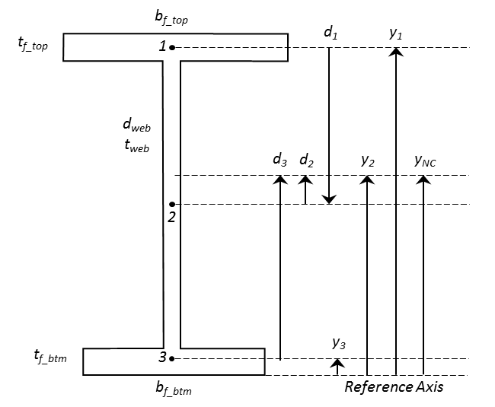

Figure . Reference diagram for calculation of non-composite section properties.

### Location of the Non-Composite Neutral Axis, yNC

The location of the neutral axis defines distance from the extreme fiber to the centroid of the cross-section. If the girder cross-section is symmetrical, the location of the neutral axis (also referred to as the location of the centroid) can be assumed as half of the depth of the girder. Otherwise, the equation for determining the location of the centroid (Equation 2 below) should be used.

|  |  |
| --- | --- |
|  | (2) |
| *Where,*  *=* *Area of each component of the cross-section.*  *= Distance to the centroid of each component from the reference axis* |  |

### Moment of Inertia, INC

The moment of inertia of the non-composite cross-section can be calculated using the Parallel Axis Theorem and the geometric properties of the girder. If the girder is a known rolled steel section, this value may be found in the AISC Steel Manual or another historical manual for rolled steel members. The equations below are used to determine the moment of inertia (for the major or minor axis) of the non-composite cross-section.

|  |  |
| --- | --- |
|  | (3) |
| *Where,*  *= Area of each component of the cross-section.*  *= Distance from the centroid of each component to the reference axis*  *= width of component base*  *= height of component base* |  |

### Section Modulus, SNC

The non-composite section modulus is used to convert the moment acting on the cross-section to the stress present in the extreme fiber due to that moment. The calculation for the section modulus is given by Equation 4 below where the major axis moment of inertia is used. Note: section modulus is defined for the top and bottom extreme fiber of the cross-section. For the non-composite section, the value for the top and bottom is the same.

|  |  |
| --- | --- |
|  | (4) |

## Composite Section Properties

Composite section properties include the stiffness contribution of the concrete deck. The Equations used to calculate long term and short term composite section properties are defined in this section.

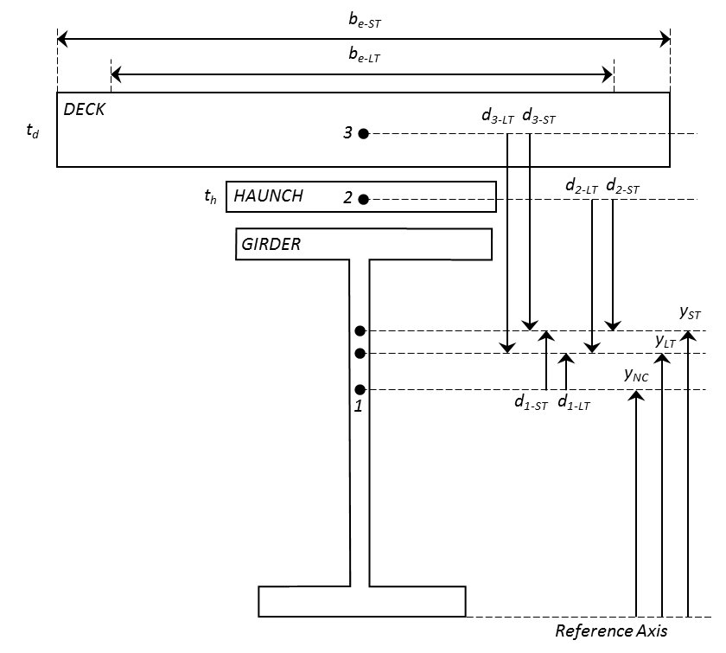

Figure . Reference diagram for calculation of composite section properties.

### Long Term vs. Short Term Composite

Long term composite section properties are used for permanent loads applied after the concrete slab has hardened (i.e. superimposed dead load). Short term composite section properties are used for transient loads applied after the deck has hardened (i.e. live load). Section properties are transformed into long term or short term by a factor of the modular ratio *n* as defined in Table 7 below.

Table . Modular ratio for transformation of short term and long term composite section

|  |  |
| --- | --- |
| **Modular Ratio, *n*** | Where,  = Modulus of Elasticity of Steel Girder  = Modulus of Elasticity of Concrete Deck |
| **Long Term** |  |
| **Short Term** |  |

### Effective Width & Area of Concrete Deck

The effective width (b*e*) of the concrete deck is defined as the tributary width of the deck between girders. For interior girders, the effective width is equal to half of the girder spacing. For exterior girders, the effective width is equal to half of the girder spacing plus the width of the overhang, if applicable. The effective width is transformed into long term (b*e-LT*) and short term (b*e-ST*) effective width by dividing by the respective long term (*3n*) and short term (*n*) modular ratio. The long term (A*LT*) and short term (A*ST*) effective area of the cross-section equals the thickness of the concrete slab multiplied by the respective effective widths. If a concrete haunch exists, the cross-sectional area of the haunch should be transformed in similar fashion. The long term and short term effective width and area are used in the calculation of other long term and short term composite section properties.

### Location of the Composite Neutral Axis, yLT & yST

The location of the neutral axis defines distance from the extreme fiber to the centroids of the long term and short term composite cross-sections. Equation 5 below is an extension of Equation 2, and can be used to determine the location of the long term and short term composite neutral axes.

|  |  |
| --- | --- |
|  | (5) |
| *Where,*  *= Area of the non-composite cross-section.*  *= Long term and short term area of each component of the cross-section.*  *= Distance to the centroid of each component from the reference axis* |  |

### Composite Moment of Inertia, ILT & IST

Equation 6 below extends Equation 3 and is used to calculate the major axis moment of inertia for the long term and short term composite section. This equation applies to sections that can be decomposed into rectangular sections such as the typical steel stringer system.

|  |  |
| --- | --- |
|  | (6) |
| *Where,*  *= Area of each component of the cross-section.*  *= Distance from the centroid of each component to the reference axis*  *= width of component base (long term/short term effective width)*  *= height of component base (i.e. thickness of deck or haunch)* |  |

### Composite Section Moduli, SLT & SST

In order to convert the moment acting on the composite cross-section to the stress present in the extreme fibers on the top and bottom of the section, the section modulus for the top and bottom of the long term and short term composite section must be calculated. To obtain these section moduli, the distances to the specific location of interest from the long term and short term composite neutral axes are needed. These can easily be calculated using the location of each of these axes and the geometric properties of the cross section. Figure 17 below depicts these values. Equations 7 through 12 are provided for the calculation of the composite section moduli.

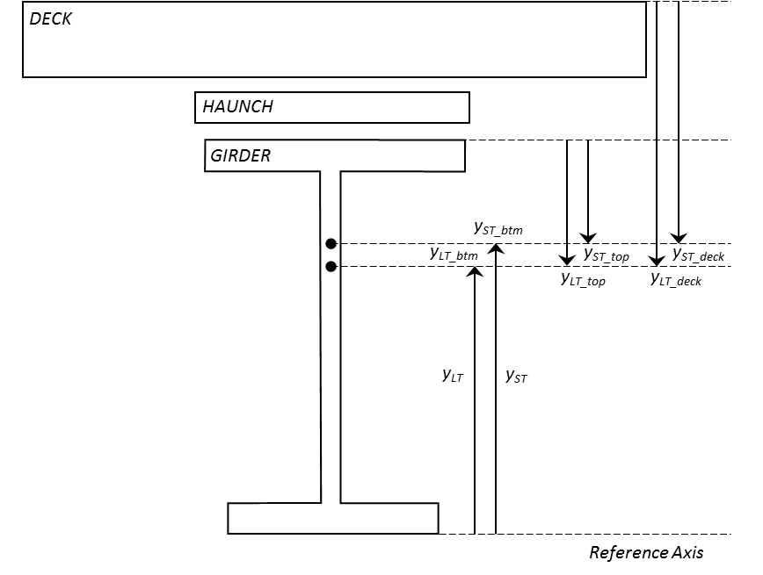

Figure . Reference diagram for calculation of long term and short term composite section moduli.

|  |  |
| --- | --- |
|  | (7, 8) |
|  | (9, 10) |
|  | (11, 12) |

## Resistance Calculations

Strength I, Service II, and Shear capacities are calculated per AASHTO LRFD Specifications. For single span bridges, positive flexure resistance is evaluated at mid-span and shear resistance is evaluated over the supports. For multiple-span continuous bridges, positive and negative flexure resistance is evaluated at the location of maximum positive and negative flexure, and shear resistance is evaluated over the supports. Positive flexure resistance of a composite section follows the provisions of AASHTO LRFD Article 6.10.7. Negative flexure resistance of composite and non-composite sections follow the provisions of AASHTO LRFD Article 6.10.8. Shear resistance follows the provisions of AASHTO LRFD Article 6.10.9.

#### Strength I Positive Flexure Resistance of Composite Section

The calculation of positive flexure resistance is dependent on if the section is compact (AASHTO LRFD Article 6.10.7.1) or non-compact (AASHTO LRFD Article 6.10.7.2). The following steps should be used to calculate the positive flexure capacity of a composite compact or non-compact section. These steps were adapted from the *Flowchart for LRFD Article 6.10.*7 found in Appendix C6 of the AASHTO LRFD Specifications.

##### Determine the plastic moment and plastic neutral axis of the composite section.

The plastic moment (*Mp*) of the composite section is the resultant moment of the forces/stresses of the section at full plasticity. The plastic moment can be determined using the procedures outlined in AASHTO LRFD Appendix D6. Note: rebar may be ignored in this calculation, which will result in a more conservative value for the plastic moment capacity.

##### Determine if the section qualifies as compact or non-compact.

Composite sections in straight bridges that satisfy the requirements listed in Table 8 shall qualify as compact and should follow the provisions of AASHTO LRFD Article 6.10.7.1. Otherwise, the section is considered non-compact and should follow the specifications of AASHTO LRFD Article 6.10.7.2. If the section qualifies as compact, continue to step 3. Otherwise, move directly to step 5.

Table . Compact requirements for composite sections in positive flexure.

|  |  |
| --- | --- |
| **Compact Requirements** | **AASHTO Article** |
|  | 6.10.6.2.2 |
|  | 6.10.2.1.1, 6.10.6.2.2 |
|  | 6.10.6.2.2-1 |

##### Compute the yield moment of the compact composite section.

The yield moment of the composite section can be determined using the provisions of AASHTO LRFD Appendix Article D6.2.2. The yield moment of a composite section in positive flexure shall be taken as the sum of the moments applied separately to the steel, short-term, and long-term composite sections to cause nominal first yielding in either steel flanges at the strength limit state, disregarding flange lateral bending (AASHTO LRFD Bridge Design Specifications, 2014). The yield moment is the sum of the total permanent loads plus the additional moment needed to cause nominal first yielding, and is taken as the lesser value calculated for the compression and tension flanges. The following equations can be used to determine the yield moment of the composite section in positive flexure.

|  |  |
| --- | --- |
|  | (13) |
|  | (14) |
|  | (15) |
|  | (16) |
|  | (17) |
| *Where,*  *= Long-term composite section modulus of top flange*  *= Long-term composite section modulus of bottom flange*  *= Short-term composite section modulus of top flange*  *= Short-term composite section modulus of bottom flange*  *= Maximum positive moment due to initial dead load*  *= Maximum positive moment due to superimposed dead load*  *= Maximum positive moment due to wearing surface*  *= Yield moment for positive flexure* |  |

##### Determine the nominal flexural resistance for the compact section.

The nominal flexural resistance for a compact composite cross-section in positive flexure is represented in the form of a moment (*Mn*) and is given by the provisions of AASHTO LRFD Article 6.10.7.1.2. Equations 18 and 19 are used to determine nominal moment resistance for simply supported bridges. Equations 20 and 21 are used to determine nominal moment resistance for multiple-span continuous.

|  |  |
| --- | --- |
|  | (18) |
|  | (19) |
|  | (20) |
|  | (21) |
| *Where,*  *= Distance from the top of the concrete deck to the neutral axis of the composite section at the plastic moment (in.)*  *= Total depth of the composite section*  = *Hybrid factor as specified in AASHTO Article 6.10.1.10.1 (for sections with differing yield strength)* |  |

##### Determine the nominal flexural resistance for the non-compact section.

The nominal flexural resistance for a non-compact composite cross-section in positive flexure is represented in the form of a stress (*Fn*) and is given by the provisions of AASHTO LRFD Article 6.10.7.2.2. Equations 22 through 24 are used to determine nominal flexural stress resistance of a composite cross-section in positive flexure.

|  |  |
| --- | --- |
|  | (22) |
|  | (23) |
|  | (24) |
| *Where,*  *= Yield strength of tension flange.*  *= Hybrid factor as specified in AASHTO Article 6.10.1.10.1 (for sections with differing yield strength)*  = *Web load-shedding factor determined as specified in AASHTO LRFD Article 6.10.1.10.2* |  |

#### Strength I Negative Flexure Resistance of Composite & Non-Composite Section

The nominal flexure resistance of a cross-section in negative flexure is taken as the lesser value calculated for the continuous or discretely braced flanges in tension or compression. A flange in tension or compression is considered continuously braced if connected to a continuous structural component such as a continuous concrete deck. Otherwise, the flange is considered discretely braced. The resistance to tension or compression of the continuous or discretely braced top flange is specified by AASHTO Article 6.10.8.3 and is given by Equation 25 below.

|  |  |
| --- | --- |
|  | (25) |
| *Where,*  *= Hybrid factor as specified in AASHTO Article 6.10.1.10.1 (for sections with differing yield strength)* |  |

The nominal resistance of a discretely braced flange in compression is taken as the lesser of the flange local buckling resistance (FLB) and the lateral torsional buckling resistance (LTB). FLB and LTB resistances are specified in AASHTO Articles 6.10.8.2.2 and 6.10.8.2.3, respectively. The following steps should be used to calculate the FLB, LTB, and overall nominal flexural resistance for a discretely braced compression flange in negative flexure.

##### Determine the compression flange local buckling resistance (FLB) per AASHTO 6.10.8.2.2.

The calculation for the FLB resistance differs depending on whether the compression flange is compact or non-compact as defined by the slenderness ratio for the compression flange (λf) and the limiting slenderness ratios for a compact (λpf) and non-compact (λrf) flange. The slenderness ratio for the compression flange and the limiting compact and non-compact ratios are listed in Table 9.

Table . Compression flange slenderness ratios for flange lateral buckling resistance of non-composite sections in negative flexure.

|  |
| --- |
| **Slenderness Ratios** |
|  |
|  |
|  |

The FLB resistance for a compact and non-compact compression flange is given by Equations 26 and 27, respectively.

|  |  |
| --- | --- |
|  | (26) |
|  | (27) |

##### Determine the lateral torsional buckling resistance of the compression flange (FLT) per AASHTO 6.10.8.2.3.

The calculation of the LTB resistance of the compression flange differs depending on whether the unbraced length of the compression flange is compact, non-compact or slender. The limits for compact unbraced length (Lp) and non-compact unbraced length (Lr) are given in Table 10.

Table . Limits of unbraced length for the compression flange lateral torsional buckling resistance of non-composite sections in negative flexure.

|  |
| --- |
| **Limits for Compact and Non-Compact Unbraced Length** |
|  |
|  |

The LTB resistances for a compact, non-compact, and slender unbraced length are given by Equations 28, 29, and 30 respectively.

|  |  |
| --- | --- |
|  | (28) |
|  | (29) |
|  | (30) |
|  |  |

In some cases, a larger value of the moment gradient modifier (Cb) can be calculated, effectively increasing the value of LTB resistance. These guidelines assume a conservative minimum value of 1.0 for Cb. Refer to AASHTO LRFD Article 6.10.2.3 for the actual calculation of Cb.

##### Determine nominal flexure resistance for the compression flange of the cross-section in negative flexure.

The lesser of the FLB and LTB resistances shall be taken as the nominal flexure resistance for the compression flange of the cross-section in negative flexure, as given by Equation 31.

|  |  |
| --- | --- |
|  | (31) |

#### Service II Flexure Resistance

Flexural resistance for the Service II limit state is determined per the provisions of AASHTO LRFD Article 6.10.4. Equations 32 and 33 are used to determine the flexural resistance for the Service II limit state.



|  |  |
| --- | --- |
|  | (32) |
|  | (33) |
| *Where,*  *= Hybrid factor as specified in AASHTO Article 6.10.1.10.1 (for sections with differing yield strength)* |  |

#### Shear Resistance

The nominal shear resistance shall be determined as specified in AASHTO LRFD Article 6.10.9.2 for unstiffened webs and Article 6.10.9.3 for stiffened webs. The following steps should be used to calculate the nominal shear resistance for unstiffened and stiffened webs.

##### Determine if the web is stiffened.

The unbraced length of the web (Lb) shall be taken as the distance between transverse stiffeners. For a web without longitudinal stiffeners, if the unbraced length of the web is less than three (3) times the depth of the web (dw), the web shall be considered stiffened. For a web with one or more longitudinal stiffeners, if the unbraced length of the web is less than 1.5 times the depth of the web, the web shall be considered stiffened. Otherwise, the web is considered unstiffened.

##### Calculate the shear buckling coefficient (*k*)*,* and the ratio of shear buckling resistance to shear yield resistance (C).

If the web is stiffened, the shear bucking coefficient is calculated using Equation 34 below. Otherwise, the shear buckling coefficient is taken as k = 5.0.

|  |  |
| --- | --- |
|  | (34) |

The ratio (C) of shear buckling resistance to shear yield resistance is determined as specified below.

|  |  |
| --- | --- |
|  | (35) |
|  | (36) |
|  | (37) |

##### Calculate the plastic shear force (Vp).

Equation 38 is used to calculate the plastic shear force.

|  |  |
| --- | --- |
|  | (38) |

##### Calculate the nominal shear resistance.

For stiffened webs, the calculation of the nominal shear resistance is different depending on the location along the girder the resistance is being calculated. A web panel is considered an *interior panel* if it is located at an interior section of the girder. The nominal shear resistance of a stiffened web interior panel is specified in AASHTO LRFD Article 6.10.9.3.2 and is calculated using equations X through X below. A web panel located at the end of a girder is considered an *end panel*. The nominal shear resistance of a stiffened web end panel and an unstiffened web is specified in AASHTO LRFD Articles 6.10.9.3.3 and 6.10.9.2, respectively, and is calculated using Equations 39 through 42 below.

|  |  |
| --- | --- |
|  | (39) |
|  | (40) |
|  | (42) |

# Load Rating

The Load and Resistance Factor Rating (LRFR) provisions detailed herein have been adopted from the 2nd Edition of the AASHTO Manual for Bridge Evaluation. All initial load ratings are based on the existing structural conditions, material properties, and loading conditions provided in construction documents, inspection reports, or by field visit. Only permanent and vehicular loads are considered in the initial load rating. Load ratings are calculated at each location where a RV was placed. For a typical multi-girder bridge, flexure and shear ratings are calculated for each member at the locations of maximum flexure and shear response to the total demand envelope. Equation 43 below gives the basic load rating equation used for initial load ratings.

|  |  |
| --- | --- |
|  | (43) |
| *Where,*  *= System factor*  *= Condition factor*  *= Factored nominal resistance*  *= LRFD load factor for permanent structural components*  *= Dead load response due to permanent structural components*  *= LRFD load factor for wearing surfaces and utilities*  *= Dead load response due to wearing surface and utilities*  *= LRFD load factor for live load evaluation*  *= Live load response due to vehicular traffic* |  |

## System & Condition Factor

The condition factor provides a reduction to account for the increased uncertainty of the resistance of deteriorated members (AASHTO Manual for Bridge Evaluation, 2014). Condition factors are optional and are left to the discretion of the evaluating engineer. Optional condition factors are provided in AASHTO Manual for Bridge Evaluation Article 6A.4.2.3, and repeated in Table 11 below.

Table . Condition Factors.

|  |  |
| --- | --- |
| **Structural Condition of Member** | ϕC |
| Good | 1.00 |
| Fair | 0.95 |
| Poor | 0.85 |

System factors are applied to the nominal resistance to reflect the level of redundancy of the superstructure (AASHTO Manual for Bridge Evaluation, 2014). The resistance of a less redundant structure is reduced, resulting in a lower rating. System factors are provided in AASHTO Manual for Bridge Evaluation Article 6A.4.2.4, and repeated in Table 12 below.

Table . System Factors.

|  |  |
| --- | --- |
| **Superstructure Type** | ϕS |
| Welded members in Two-Girder/Truss/Arch Bridges | 0.85 |
| Riveted members in Two-Girder/Truss/Arch Bridges | 0.90 |
| Multiple Eyebar Members in Truss Bridges | 0.90 |
| Three-Girder Bridges with Girder Spacing of 6ft | 0.85 |
| Four-Girder Bridges with Girder Spacing ≤ 4ft | 0.95 |
| All Other Girder and Slab Bridges | 1.00 |
| Floor-beams with Spacing > 12ft and Non-Continuous Stringers | 0.85 |
| Redundant Stringer Subsystems between Floor-beams | 1.00 |

## Nominal Resistance

Table 13 below summarizes the values of resistance that are evaluated in the load rating calculation. The dead and live load responses to be used in this equation are dependent on the units (units of moment or units of stress) of the resistance calculated for the cross-section.

Table . Values of resistance used for load rating.

|  |  |  |
| --- | --- | --- |
| **Case** | **Strength I Resistance** | **Service II Resistance** |
| Compact, Composite Section in Positive Flexure | Mn [lb-in], [k-ft] | Fn [lb/in2], [k/in2] |
| Non-Compact, Composite Section in Positive Flexure | Fn [lb/in2], [k/in2] | Fn [lb/in2], [k/in2] |
| Non-Composite Section in Negative Flexure | Fn [lb/in2], [k/in2] | Fn [lb/in2], [k/in2] |
| Section in Shear | Vn [lb], [k] | NA |

## LRFD Load Factors for Resistance, Dead Load, and Live Load

Table 14 below provides the LRFD load factors for resistance, dead load, and live load, adopted from AASHTO Manual for Bridge Evaluation Article 6.4.2.2.

Table . Load and resistance factors for load rating.

|  |  |  |
| --- | --- | --- |
| **FACTORS** | Strength I | Service II |
| Capacity (ϕ) | 1.00 | 1.00 |
| Capacity (ϕ) | 1.00 | 1.00 |
| Dead Load (γDC) | 1.25 | 1.00 |
| Wearing Surface (γDW) | 1.50 | 1.00 |
| LL: Inventory (γLL) | 1.75 | 1.30 |
| LL: Operating (γLL) | 1.35 | 1.00 |
| Legal Loads: Inv. (γLL) | 1.45 | 1.30 |
| Legal Loads: Op. (γLL) | 1.45 | 1.00 |

## Reporting of Controlling Load Rating

The minimum controlling rating for Strength I, Service II Flexure, and Shear is reported for the structure.

# References

AASHTO, American Association of State Highway and Transportation Officials. (2014). AASHTO LRFD Bridge Design Specifications. *6th Edition*. Washington, D.C.: American Association of State Highway and Transportation Officials.

AASHTO, American Association of State Highway and Transportation Officials. (2014). AASHTO Manual for Bridge Evaluation. *2nd Edition*. Washington, D.C.: American Association of State Highway and Transportation Officials.

David M. Masceri, P. (2015, September). Examination of Bridge Performance through the Extension of Simulation Modeling and Structural Identification of Large Populations of Structures. *Doctorial Dissertation*.

David Masceri, J. B. (2014). *NCHRP 12-103 Bridge Superstructure Tolerance to Total and Differential Foundation Movements Phase I Report.* Transportation Research Board. Washington, D.C.: National Cooperative Highway Research Program.

White, e. a. (2012). *NCHRP 12-79 Guidelines for analytical Methods and Erection Engineering of Curved and Skewed Steel Deck-Girder Bridges.* Transportation Research Board. Washington, D.C.: National Cooperative Highway Research Program.